Installing the TCM Jaggaer Word Application
- The Word App only needs to be installed once on each device that you will be using.
- Follow these instructions to get the add-in(s) for Production (Red) or Test (Gray), depending on the application(s) you will be using

- Open a blank Word Document. Go to the INSERT tab on the ribbon, and click My Add-ins:
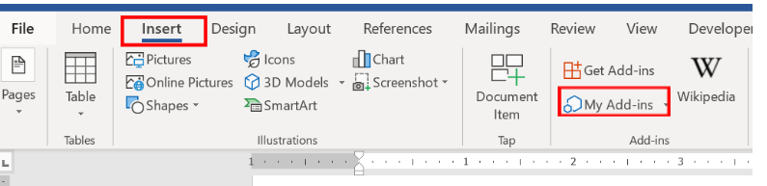

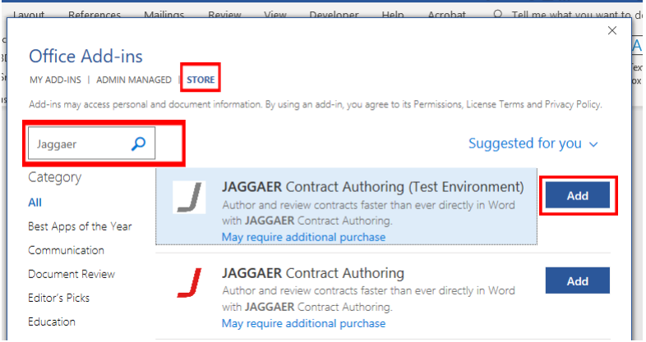
- Next, go to the STORE ribbon on the popup box and search for “Jaggaer”. You will see two add-ins: the production environment in red and test environment in gray. Click Add to install the add-in. If you need both production and test, you will have to install these one at a
time.
- If you get an error when trying to install the add-in, follow the instructions in this step; otherwise, skip this step and go to #4.
Go to File> Account (3rd from bottom, left hand side). Your user information will pull up. Switch account to sign-in with your UNCG account.
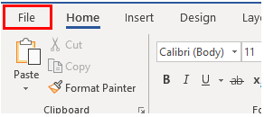
After signing in with your UNCG credentials, go back to Step 1 to get the add-in.

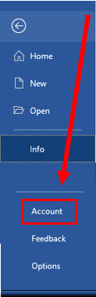

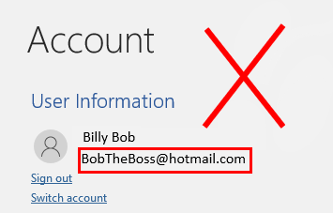
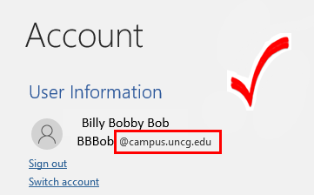

- After the Add-In is installed, click on the Show Taskpane in the upper RH side of your Word ribbon. Click on Taskpane that you are installing.
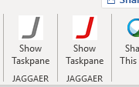
- In the right pane you will be requested to enter an Activation Code: 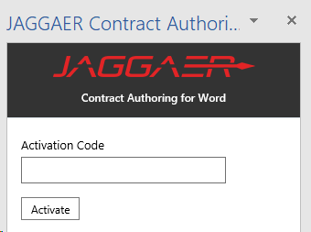

- Generating an Activation Code:
In eMarketplace (production for the red “J” and Test for the gray “J”), go to your profile. Under User Profile and Preferences, select “App Activation Codes” as shown below.
If you do not have the “App Activation Codes” option, please contact the TCM System Administrator at 336-334-4673 so that a code can be emailed to you. The emailed code will be valid for 72 hours.
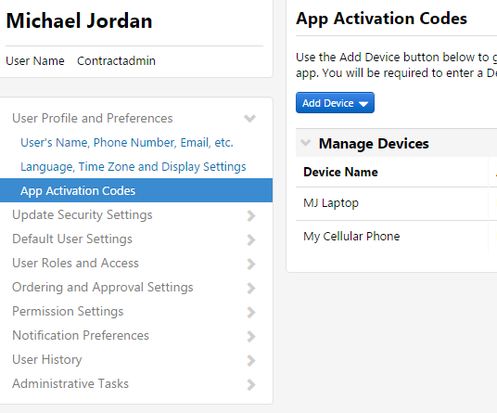
- Next Click “Add Device” (if this is the first device you have added, click on “Add Microsoft Word”.)
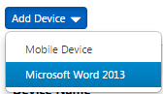

- Name the device you are using, like “Laptop” or “Desktop”. You can click “Email Activation Code to User” to send the activation code to your email inbox as well, but this is not necessary:
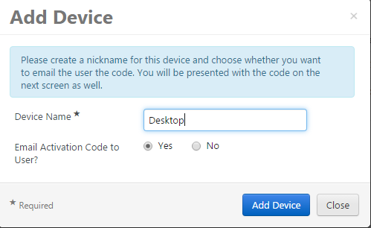

Click “Add Device”, and a code is generated:
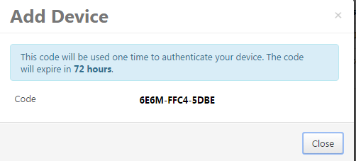

- Copy and paste this code into the Word Add-In in “Activation Code” and click Activate.

