Approving a Contract Request

NOTE: If multiple departments are in the same workgroup, you can identify your requests to approve by the prefix on the request name or by the requester’s name.
Contract Managers approve their own Requests that they are converting to contracts in the Contract Manager Review step.

- You will receive an email notifying you of a Form Request Workflow for Contract Request is Pending Approval.
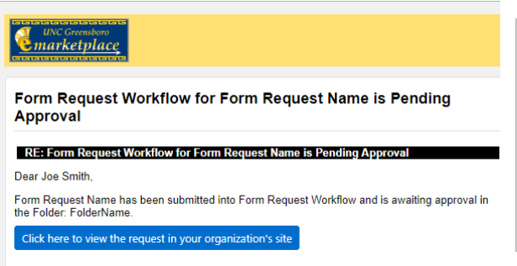

- Find the Contract Request Form to approve by clicking the blue link in the email, or by logging into eMarketplace and click Action Items, either at the top of the page, or from the Contract Management Dashboard.

If clicking on the email link, go to step #5.

- If using Action Items, click on Form Request Approvals

- The Approval Folder will display. Click on the folder to expand and view the Requests to approve. If multiple departments are in the same workgroup, you can identify your requests to approve by the prefix on the request name or by the requester’s name.

Click on the Form number to open the Form.
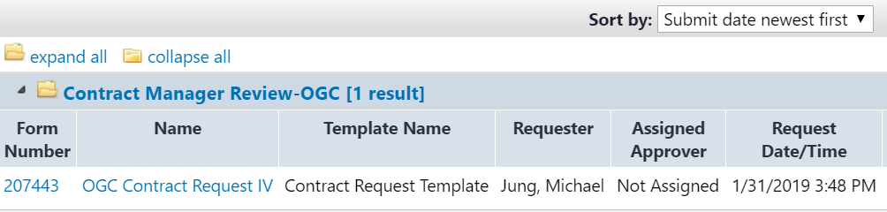

- Click the dropdown by Form Request Actions; Click Assign to Myself to take the request out of the shared folder for the Workgroup.
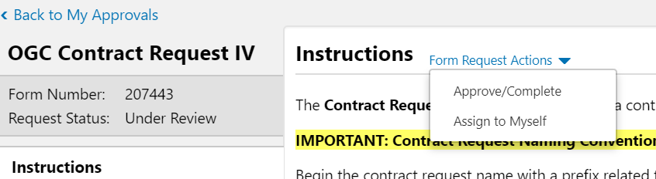

- Once assigned, further actions are available:
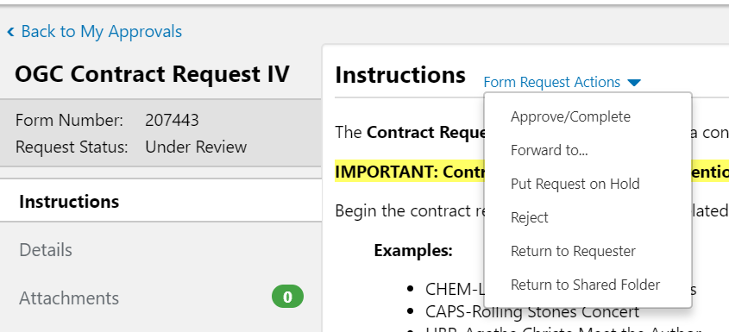

- Navigate through the contract request by clicking through the menu on the left (Details, Attachments, Questions, etc.). If something in the contract request needs to be changed, you can change the request form or Return to Requestor.

After you complete any actions you need to take on the Request, the contract request is ready to be approved. Choose Approve/Complete from the dropdown Form Request Action menu. The Contract Request must be approved before the form will continue through workflow for contract creation.

- Post a Discussion Thread if more information is needed before approving the Contract Request:
- Choose “Discussion” in the left-hand tabs menu.
- Click the Start New Thread button to begin a discussion thread on a contract request.
- Enter a title for the contract request message in the Subject field.
- Note: If there is more than one discussion on a contract request, the Subject line for each message is displayed under the Topics heading.

- Enter the text of the contract request message in the Message field.
- Click the Add Attachments button to add files or links to the contract request message (optional).
- Click Post Message to display a message on the Discussion page.
- Click the Edit button to change the text of a contract request message or reply.

- Finding Previously Approved Contract Requests. Approved requests can be searched in two ways:
  - In the Requests Ready for Contract Creation screen, click on “Filter Contract Requests” and choose status of “Completed”
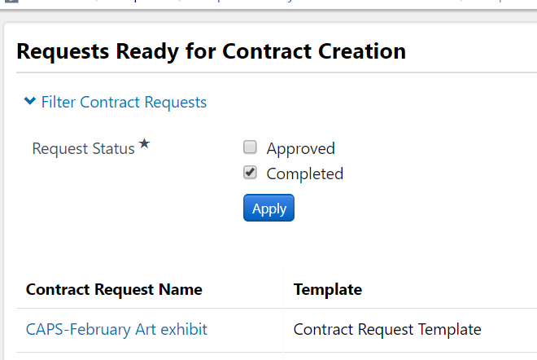
  - Go to Documents>Document Search>Search Documents. In the dropdown, search for Form Requests. Search for Form Name “Contract Request”. Add any other filters needed.
