Contract Manager/Administrator Role

Overview of role:
- Contract Managers approve requests created by Contract Requestors and create contracts from these requests.
- Contract Managers are the final approver in the contract request workflow. After approving the request, the Manager converts the request into the contract.
- Contract Managers can also create the contract directly, without having a request, unless a Sole Source (Waiver of Competition) is requested. If a Sole Source (Waiver of Competition) is requested for the contract, the sole source request must be created in the contract request and approved by Purchasing before the contract is created.
- UNCG’s standard document templates are used in TCM.
- Contract Managers involve General Counsel or Purchasing as needed if using the second party’s paper or if modifying the terms and conditions of a UNCG main document.
- UNCG signature authorities are maintained in TCM. Contract Managers can add/choose UNCG signatories and departmental addresses to the UNC Greensboro First Party record.
- Edits are required to add Statements of Work and payment terms to UNCG standard contract templates. Contract Managers must use the Jaggaer Word App in Microsoft Word to edit contracts in TCM.
- UNCG uses AdobeSign for electronic signature. The UNCG templates contain the e-signature tags. If using the other party’s document, the signature placeholders can be added manually.
- The Contract Management Dashboard has to Quick Links for contract creation, approvals and searches. The dashboard also has a quick link to the shopping home page and document search in addition to links for contract actions.
Approving a Contract Request

- Find Contract Request Forms to approve by searching Action Items, either at the top of the page, or from the Contract Management Dashboard.

Click on Form Request Approvals
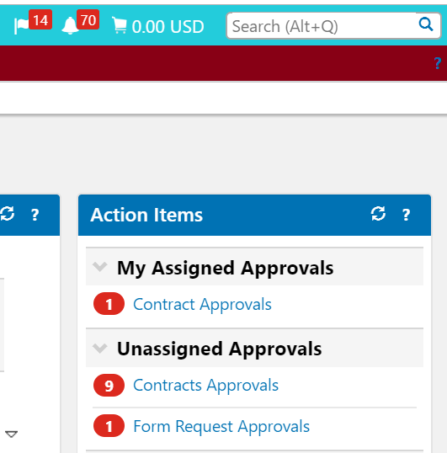

- The Approval Folder will display. Click on the folder to expand and view the Requests to approve. If multiple departments are in the same workgroup, you can identify your requests to approve by the prefix on the request name or by the requester’s name.

Click on the Form number to open the Form.
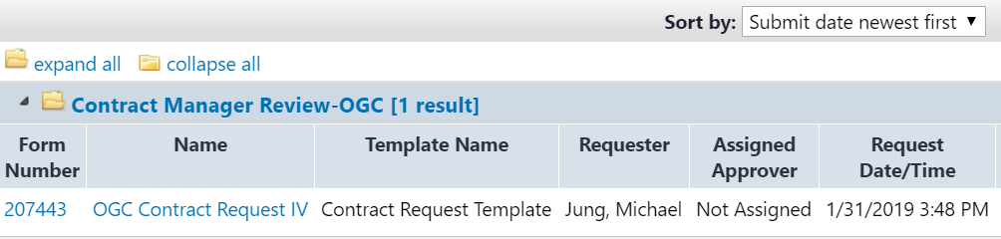

- Click the dropdown by Form Request Actions; Click Assign to Myself to take the request out of the shared folder for the Workgroup.

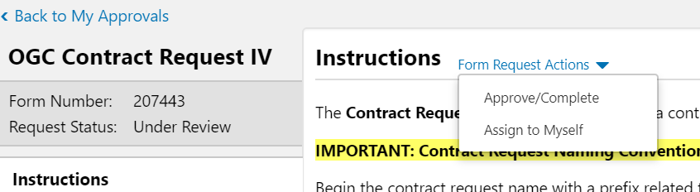

- Once assigned, further actions are available:
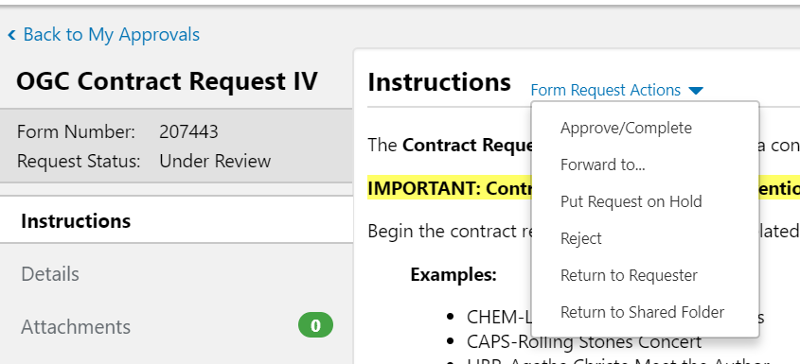

- Navigate through the contract request by clicking through the menu on the left (Details, Attachments, Questions, etc.). If something in the contract request needs to be changed, you can change the request or Return to Requestor.

- After approving the request, click Request actions and Create Contract
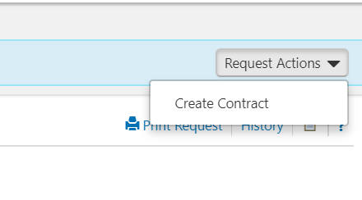
- If you want to find approved requests again, you can search in two ways:
  - In the Requests Ready for Contract Creation screen, click on “Filter Contract Requests” and choose status of “Completed”
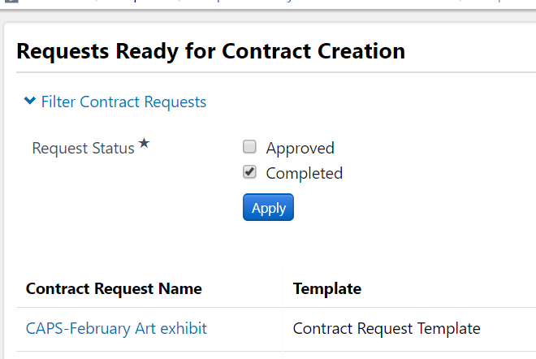
  - Go to Documents>Document Search>Search Documents. In the dropdown, search for Form Requests. Search for Form Name “Contract Request”. Add any other filters needed.
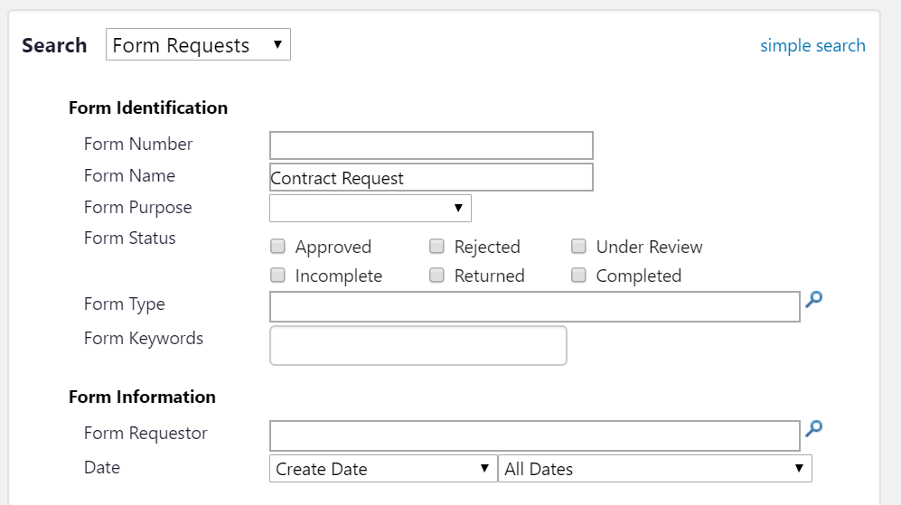
Creating a Contract

- Creating from a Contract Request. (If creating a contract without the request, go to #3)

If you are not creating the contract immediately after approving a request, you can find the approved contract request again by going to Contracts -> Requests -> Requests Ready for Contract Creation

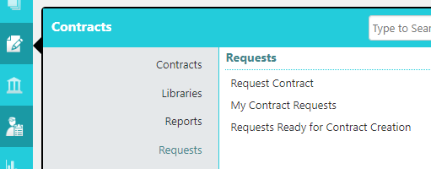

Or use the Quick Links from the Contract Management Dashboard
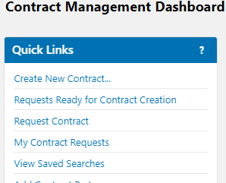

After you’ve clicked on the Requests Ready for Contract Creation link you should see a queue of fully approved contract requests. This is a shared queue for all contract managers in your workgroup, so be sure to create contracts for contract requests for which you are the manager.

Once contracts are created from these requests they will be removed from this list.

- Click on a contract request to open it and under Request Actions, click Create Contract. Complete the requested information about the Contract and indicating which attachments to copy to the contract.
Go to Step #4

- Creating a New Contract not using a Contract Request form.
Create the contract either from the Dashboard Quick Link or from the Contracts sidebar menu:
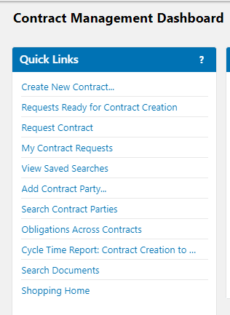
OR
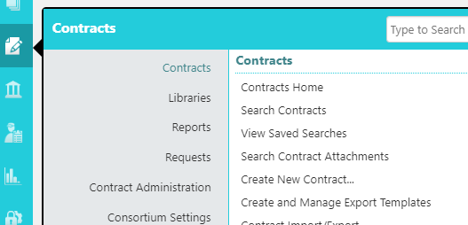
Complete the requested fields. If using a UNCG standard template, choose it as the Main Document Template. If using the other party’s template, leave Main Document Template blank. Click Create Contract.
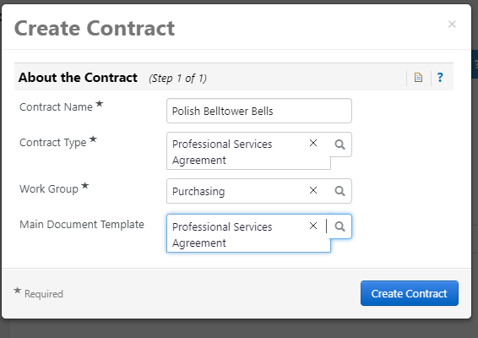

- The Contract number is assigned and the status is always displayed in the upper LH corner. The Gray area under the Contract Number will display information about the contract.

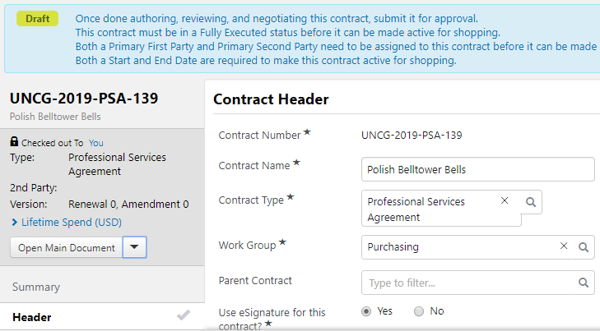

- Complete the contract information by navigating the LH panel. Sections can be completed in any order; fields marked with * are required.
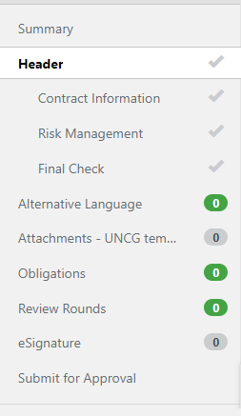

- Extra Notes about the Contract Sections:

  - HEADER
    - Work Group: If your work group is not listed, contact Purchasing
    - Use eSignature for this Contract: The default is “yes”. If you are uploading a previously signed contract choose “no”
    - Summary: A brief 1-3 sentences so that the contract can be identified at a glance
    - Contract Parties:
- First Party is UNC Greensboro. Under Actions, Edit the Contact and the Address (add contact and department address if they do not exist)
- Second Party is the party UNCG is contracting with. Edit the Contact and Address (add the contact name if it does not exist; the address should be chosen from the address options, usually one of the Purchasing Vendor/ Fulfillment addresses

    - Start Date – Update Start Date Upon Execution: Check if the contract states that contract begins with the date of the last signature. UNCG templates have this statement. If uploading a fully signed document, you will have the chance to update the start and end date
    - Auto-renew: Generally, set to “no”. If a contract auto-renews, contact Purchasing or OGC.
    - Additional Details>Keywords: Enter any keywords that may be helpful for future searches
    - Risk Assessment: Read the help text (?) to determine the risk level.

  - ATTACHMENTS
    - If you did not choose a main document when starting the contract, you can click ‘Upload Main Document’ drop-down menu. Click the ‘Use a Template’ option and choose the UNCG contract template associated with the contract type or choose ‘Upload Main Document’ to upload the second party’s template. It will take a few minutes for the contract to show up on the attachments screen.
    - UNCG Templates: The UNCG template will be the Main Document.
- Click on the template name to download it
- Open the document and click on the Jaggaer app
- Click on “Checkout” if this option shows in the Jaggaer App pane
- Enter the scope of work for the services and payment details
- Check the Notices to remove any uncompleted placeholders
- If the template is to be negotiated/modified by the other party, turn on Track Changes
- When all edits are complete, Check In the document to return to TCM.
- Keep the contract checked out to me: If this box is checked, you will not have to check out the contract again when you return to TCM
    - Other Party Word Template: Request a Word version from the supplier for the document to be red-lined by Purchasing or General Counsel. Most suppliers will comply if asked. If you cannot obtain the Word version, upload the pdf as the main document.
- Upload the template as the main document
- Open the document and click on the Jaggaer app
- Checkout if this option is in the Jaggaer App pane
- Turn on Track Changes
- Check In the document to return to TCM.
- Keep the contract checked out to me: If this box is checked, you will not have to check out the contract again when you return to TCM
    - PDF Contracts:
Upload the pdf as the main document
    - Replacing a main document template with a new version
If the supplier sends back a red-lined version of the contract, remove the current main document and upload the new version.
    - Other Attachments
- Any attachments brought over from a Contract Request will be listed.
- Attach any other documents pertinent to this contract
- From Actions choose whether you want any of the attachments to print with the main contract (green checkmark) or not (red x). Printing with the main document means that the attachment will go to the supplier, so check carefully what you want to print.

- OBLIGATIONS:
- Add any required COI obligation from the Library and change any due dates and advance notice dates. The Contract Manager can mark the obligation complete by uploading the COI on the obligation tab. Risk Management is notified of past due obligations.
- If UNCG as a contract party is required to submit a COI, that can also be uploaded here.

- REVIEW ROUNDS:
    - Internal
- Required for Other party or UNCG templates with Terms & Conditions modified
- Required for Department Head to sign Contract Advisory if contract contains normally unacceptable clauses
- Can be used any time other opinions are needed in the creation of a contract
- After entering the names of the reviewers, click Begin Round

- External
- Use to send emails with attached, red-lined contracts for the other party to review/red-line
- When the contract is returned, upload it again as the main document.
- After entering the names of the reviewers, click Begin Round

- eSIGNATURE:
    - UNCG is always the first signer on UNCG templates; choose the name of the authorized signer for UNCG. Click here to see the list of Delegated Signature Authorities for UNCG. If you still have questions about who should sign a particular contract for UNCG, contact Office of General Counsel.
    - Choose the second signer’s name
    - If UNCG template, the signature blocks are already assigned in the contract as Signer 1 (UNCG) and Signer 2 (other party)
    - If using the second party’s template, the signature fields can be dragged onto the contract after approvals, when you launch signature; otherwise Adobe will default the signatures to the bottom of the document

- ePROCUREMENT SETUP:
Check “yes” for the contract to be applied to Purchase Orders created. If multiple contracts exist for a supplier, you will be given a choice of which contract to use when you create your requisition.

- COMMENTS & COMMUNICATION CENTER:
- Comments can be added to give more information about a contract, especially information that an approver in workflow may find helpful. Comments can be emailed to others when they are created; however, the email does not show on the comment so there is no record of sending the comment.
- The Communication Center is used to create email threads that do show the email recipient(s)

- SUBMIT FOR APPROVAL:
- If all tabs have green checks, you can submit for approval.
- If not, return to the tabs in question and complete the answers before submitting
- You can see the workflow approvals by click on View Approvals before submitting or on Approvals after submitting.

- Contract Actions during contract creation
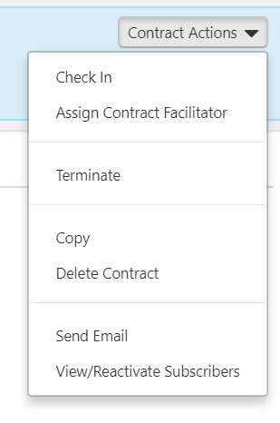

  - Check In / Check Out: You must Check Out the contract to make edits. If you need to stop working on the contract, you can check it in so that someone else can work on it. If you cannot edit the question fields, most likely you need to “Check Out”
  - Assign Contract Facilitator: A contract facilitator can be used to take over your work on a contract. Examples of this use would be if you need someone else in your workgroup to complete the contract or if General Counsel needs to review/red-line the second party’s template. The Contract Facilitator has complete control of the contract until they assign it back to you or to someone else.
  - Terminate: DO NOT TERMINATE a contract by using this action! If a contract needs to be terminated, you must send a communication to OGC or Purchasing requesting that they assist you in terminating the contract. The proper legal document must be completed and sent to the supplier before terminating a contract.
  - Copy: If you need to create a contract like an existing contract, the contract can be copied
  - Delete Contract: If you start a contract and do not want to complete it, the “delete”

Launch eSignature
(For contracts with eSignature = yes)

- After all workflow approvals have been completed, you will receive an email that your contract is ready to launch eSignature.
- Click on the link in the email to go to the contract, or go to View Saved Searches in the dashboard
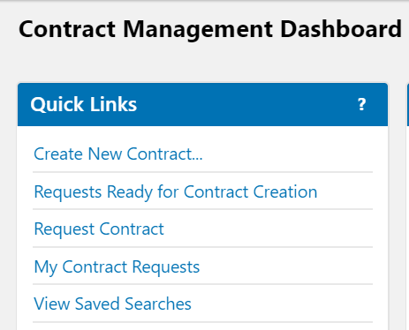

- Click on Contract Searches and click on My Contracts Pending Signature to see a list of your contracts in this status.
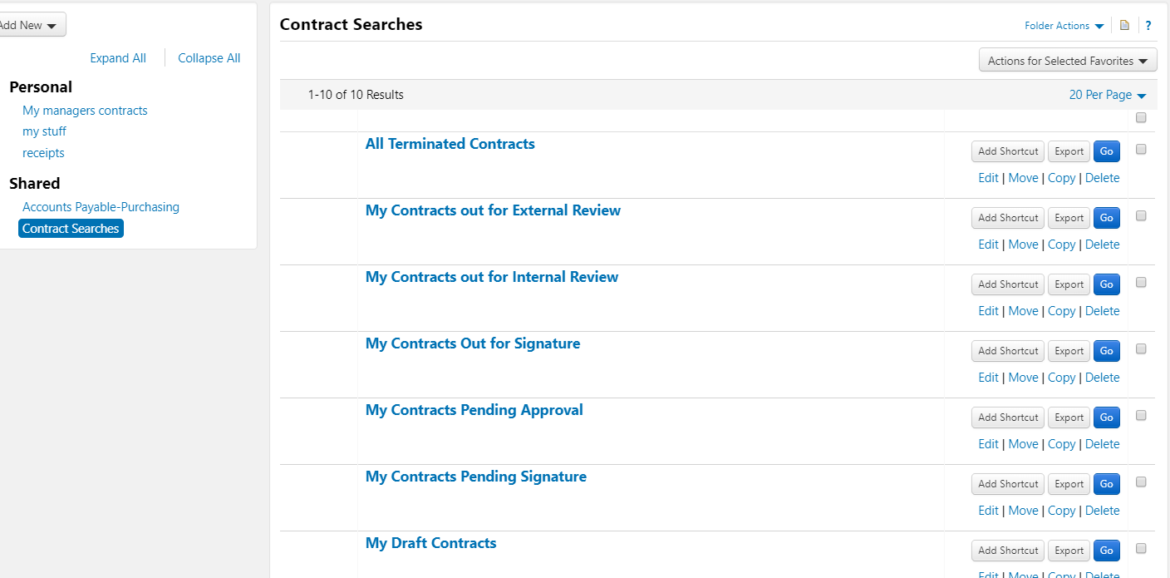

- Click on the Contract number to open the contract and in Contract Actions choose ‘Launch eSignature’.
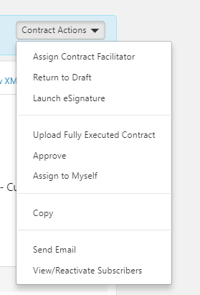

- Adobe Sign will open. Scroll to the signature section of the contract.
If a UNCG template, the signature tags are already in place.
If the second party template, you can manually set-up the signature by choosing the first recipient signer and dragging Signature (Signature Fields), and Name, Title and Date (Signer Info Fields) onto the contract. Repeat with the Signer 2.
When completed, click Send.
- NOTE: If the document does not contain Signature tags, Adobe will default the signatures at the bottom of the last page.
- The UNCG signer will receive an email with a link to sign the document. After UNCG signs, the Second Party signer will receive the email and link.
- After the document is fully executed, each signer will receive a copy of the contract via email and a copy will be returned to the TCM. After few minutes the document will be compiled and a pdf stored as the main document.

Out for Signature

- If using eSignature, the Out for Signature step will automatically complete after all signatures are obtained.

- If NOT using eSignature, click on “Upload Fully Executed Contract”

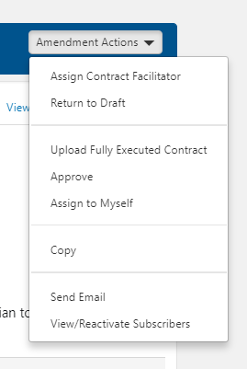

- You will have the option to upload a new document or to use the full contract pdf that you previously uploaded.
Generally, the Contract Summary Visibility should be set to “Use the Summary Configuration Settings”
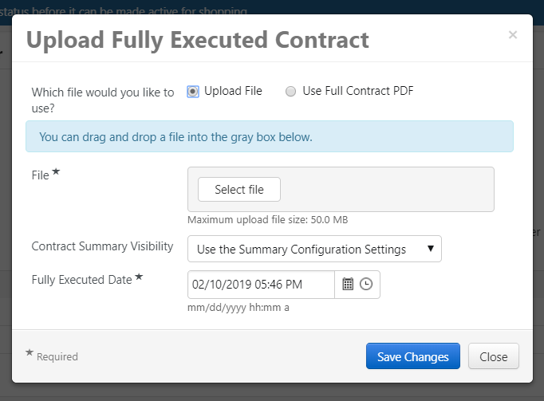

Amending a Contract

- Changes to a fully executed contract require an amendment.
- When amending a contract using a UNCG template, choose the UNCG Amendment template for the contract type. When amending the other party’s contract, use the other party’s amendment as the main document.
- Open the Fully Executed contract. Click on Contract Actions and then click on Amend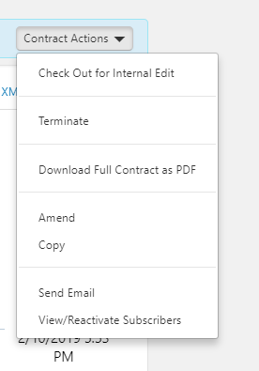

- To continue with the amendment, choose whether to include the latest attachment versions.
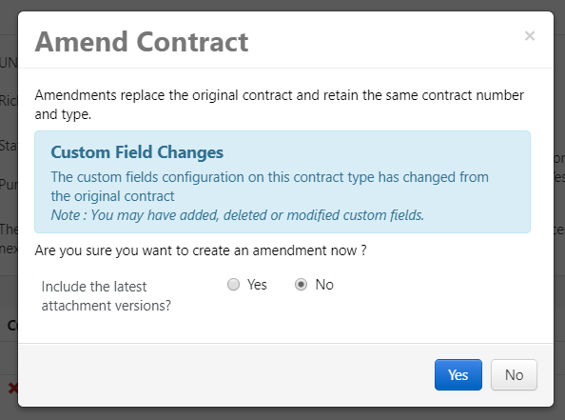

- Choosing “no” will keep the current executed contract as the main document. Choosing “yes” will move the current executed contract to “Previous Fully Executed Contract PDF” and add a new copy of the contract as the main document.

Example of “YES”: To replace the “new” version, choose “Replace as Main Document” in Actions
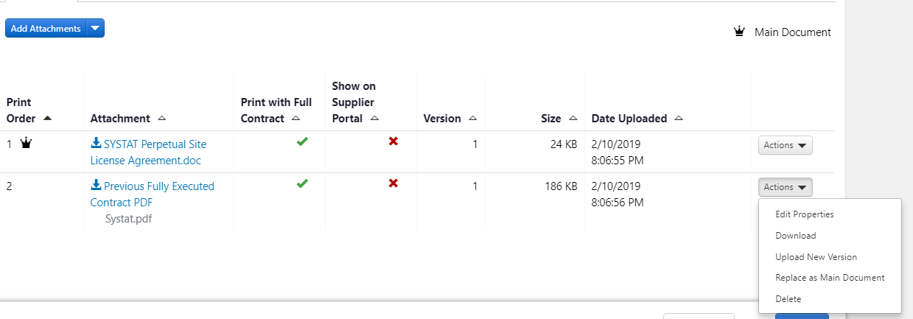

Example of “No”: To replace the “new” version, choose “Unassign as Main Document” in Actions

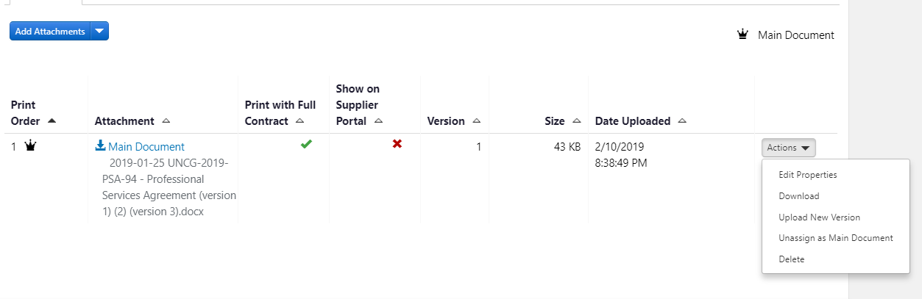

- Once you “Unassign as Main Document”, the Upload Main Document button will appear for you to add the amendment document as the new main document

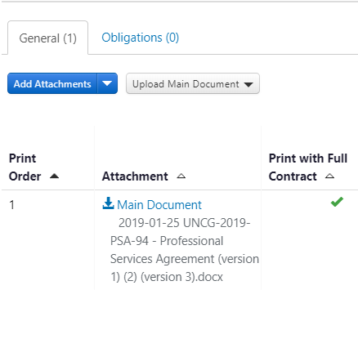

- For a UNCG contract, choose “Use a template”; for another party’s contract, choose “Upload Main Document”
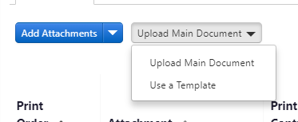

Example of “Use a Template” – choose the Amendment

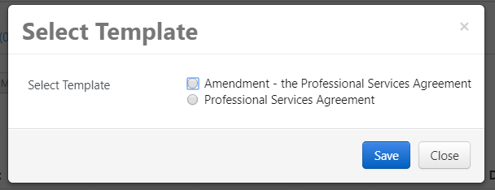

- In Edit Properties choose “no” to “print with full contract” if previous documents should not print with the amendment. (There is usually no need to send previous attachments with an amendment.)
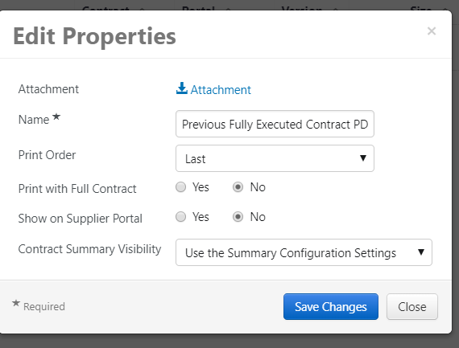

- Make the necessary changes to the contract fields for the amendment, update the Amendment template
Using the Jaggaer Word app with the needed changes.

- Submit for approval

- After approvals, launch eSignature (or upload the other party’s signed amendment)

Searching for Contracts

- The Contract Search widget is on the Contract Management Dashboard. You can search by Contract number, name or keyword. Advanced Search offers more options and is helpful for searching by contract status.
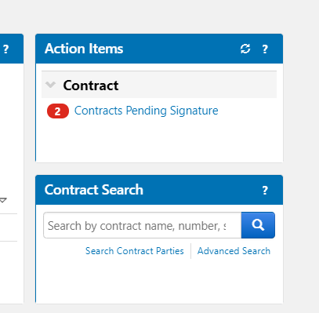

- View Saved Searches in the Quick Links contains several pre-defined searches for your own contracts based on status.
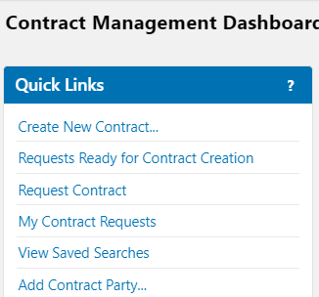

- Click on Contract Searches in the Shared folder
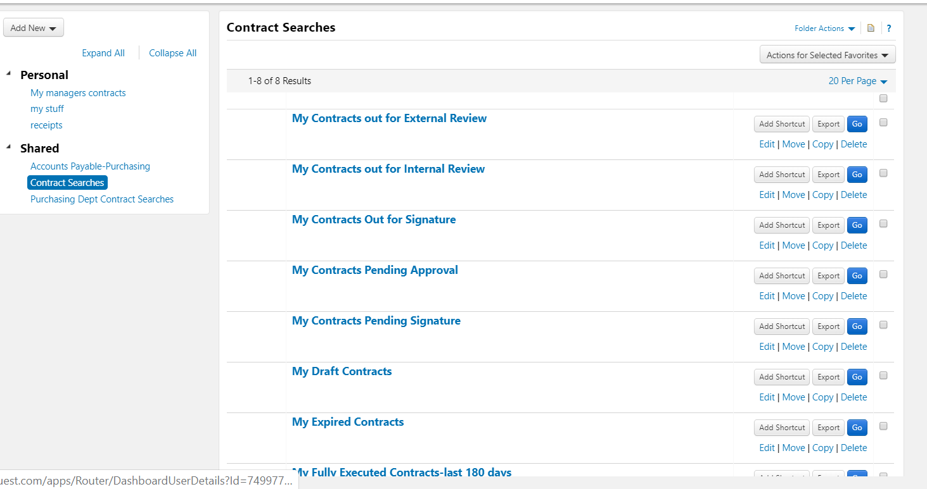

- You can create your own searches and save the searches in a Personal folder

